Technical notes of AML-Scan Tool Structure

First Step: define regulatAPIParams

Add properties in InputEvents of formKeys (views.schema.json)

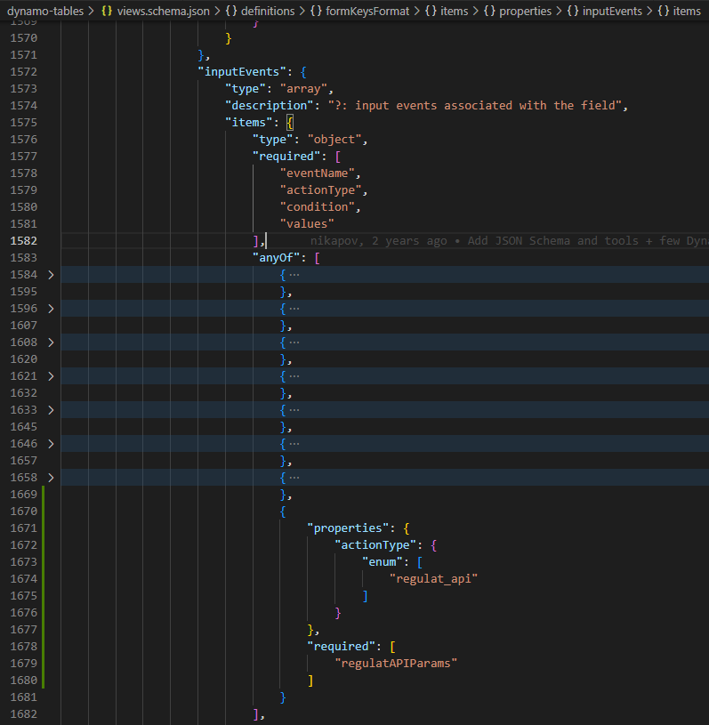

Add regulatAPIParams (views.schema.json)

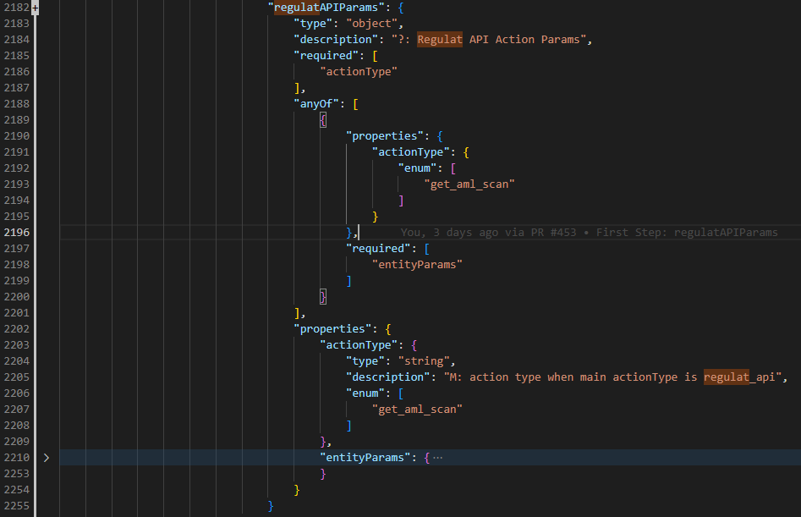

Define entityParams under regulatAPIParams (views.schema.json)

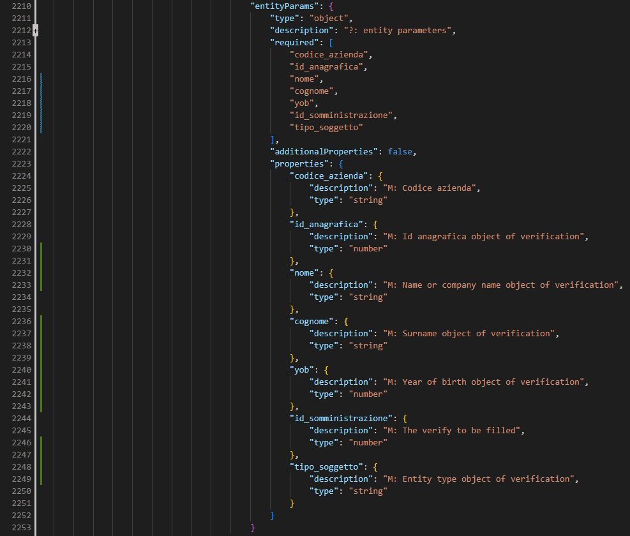

Create interface regulat_api_params.ts

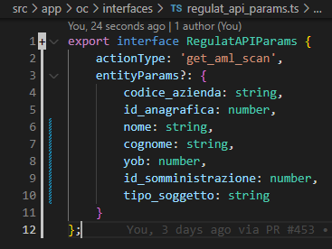

Add export path

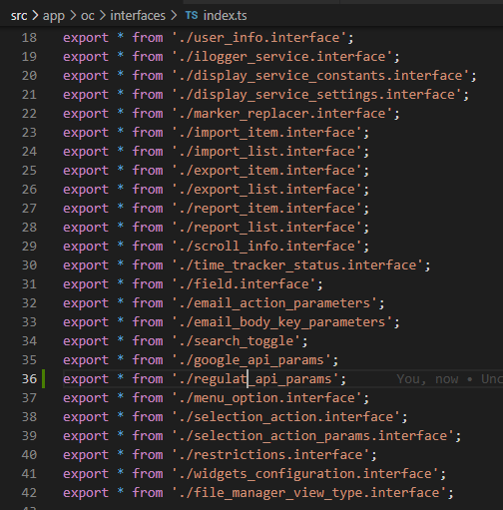

Add in fieldInputEvent in field.interface.ts

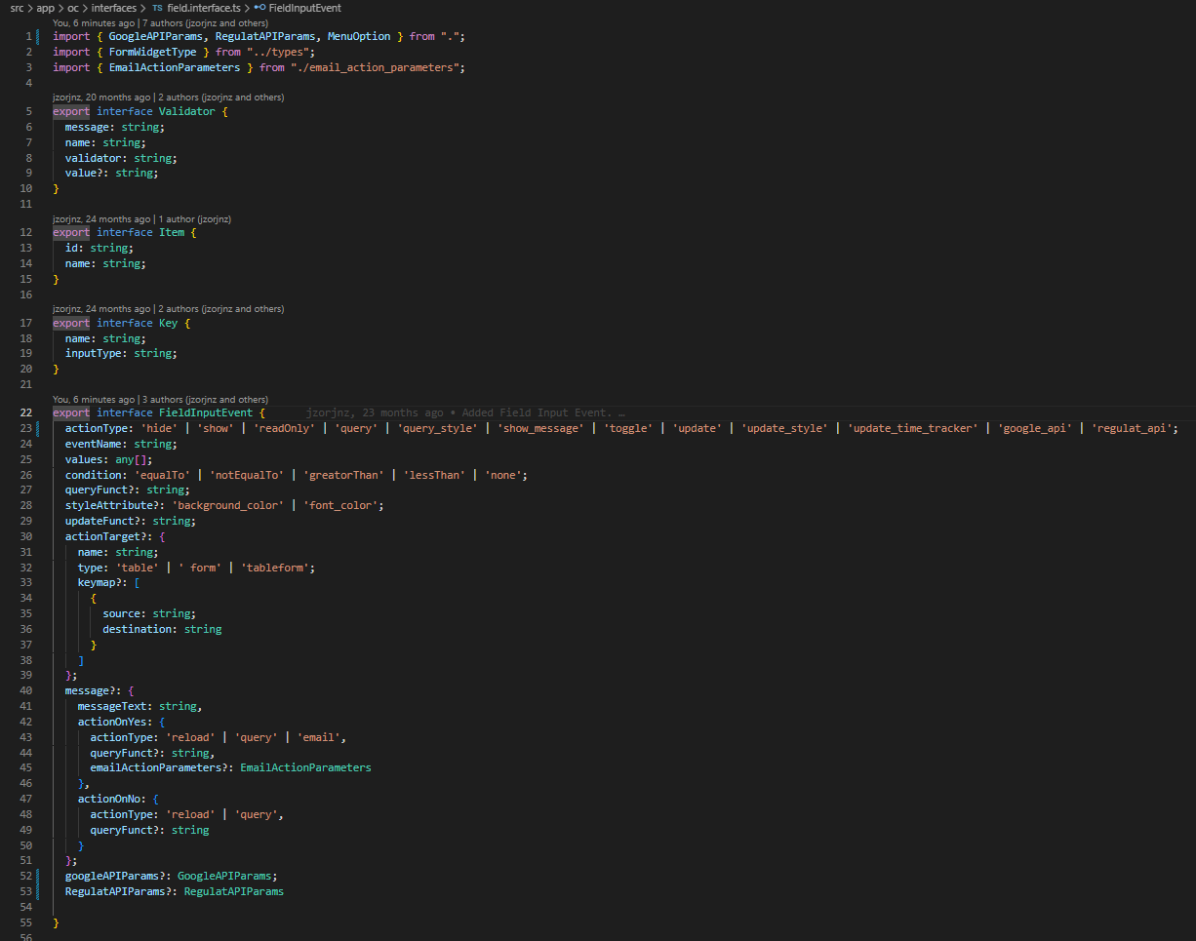

NB: After the 6 points I get this:
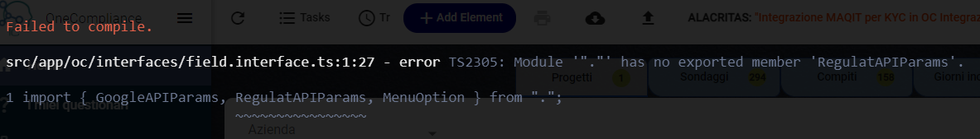
ERROR: Module ‘“.”’ has no exported member ‘RegulatAPIParams’.
/* So for now I commented it, to make the test work. The file where I commented some code are: 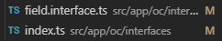
The commit has been named “Commented import interface”.
*/

Second Step: manage the flow in the backend

Add event in form-getter.component.ts (line 1381) which calls runRegulatEvent.

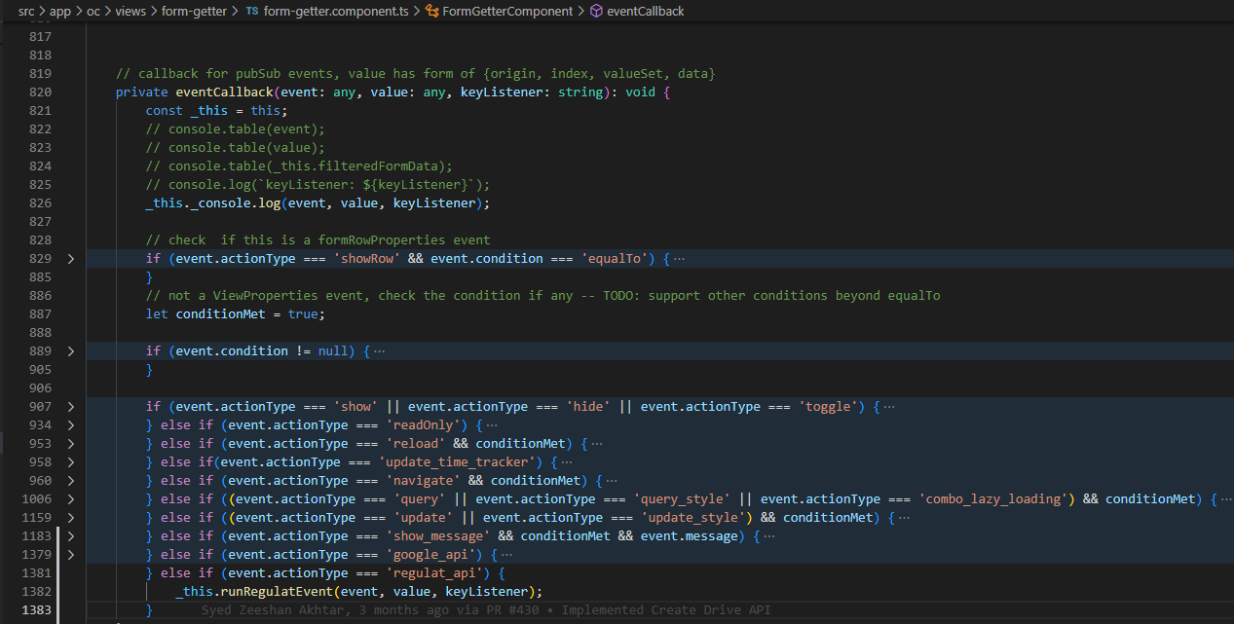

Create async function (first draft) related to the button in form-getter

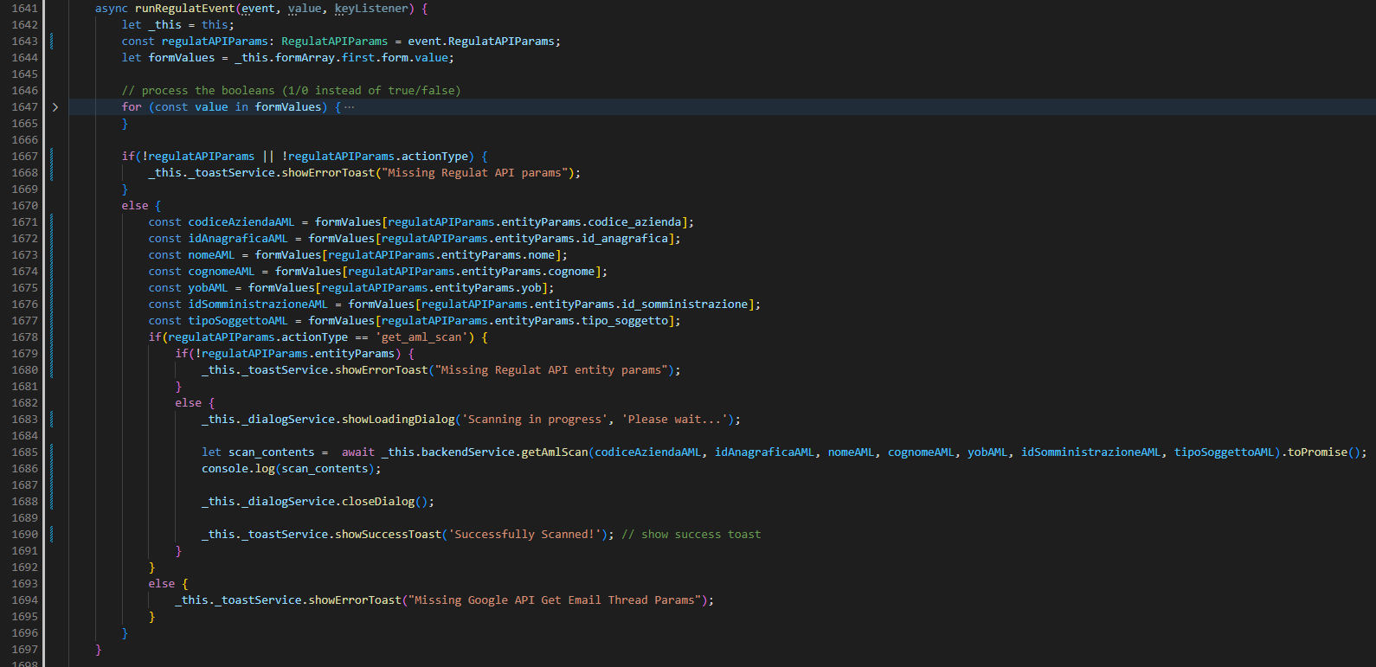

Created the method in backend.service.ts

Third Step: Create lambda functs (regulat and regulat_VPC)

Index.js of regulat
Here I do the operation to get the scan result in json format, and when the process is complete the lambda regulat_VPC will be called. Flow: Get acces token (bearer), define which api have to be called (depends on entityType) and get scan result. https://github.com/alacritascompliance/onecompliance/blob/c82990932b1fc9534f6079dc96f2db0631540b91/lambda/regulat
NB: I need to pass also the const “company”, “registry” and “checkId” with the scannedData in the payload of lambda.invoke(regulat_VPC).

Index.js of regulat_VPC
From here basically I run this query, passing the calling payload by regulat.lambda
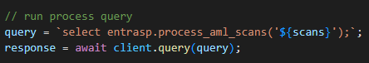

Fourth Step: Database

Table aml_scans on imports schema
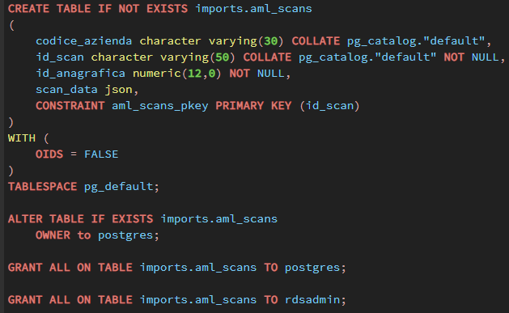
Where in the “scan” attribute I put the response “data” in json format.

entrasp.process_aml_scans(scans json) function
Insert into entrasp.aml_scans the scan result. Then loop for each new scan and insert into risposte.

